**Creat a GitHub account**

If you don’t already have a GitHub account ,here’s how to create one.

1.Open https://github.com in a web browser and and select **sign up.**

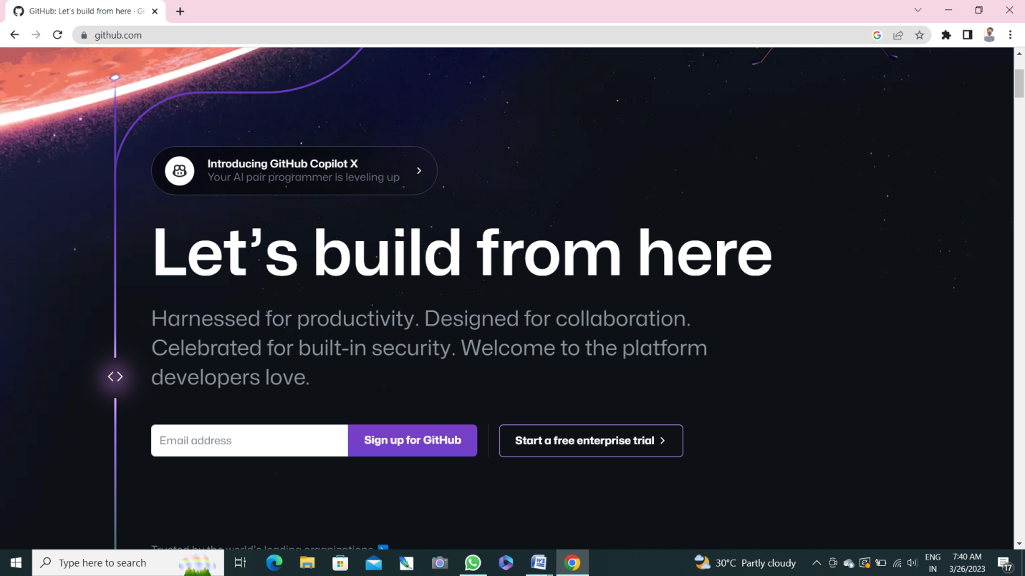

2.Enter your email address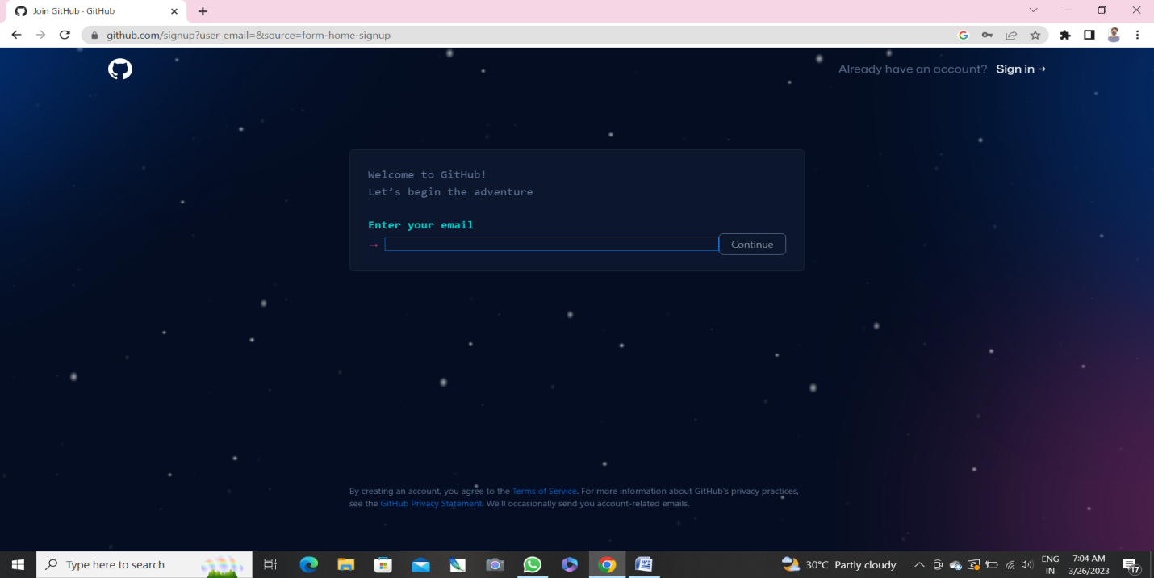3.create the password for your new github account, and enter a usertname,too Next, choose whether you want to receive updates and announcements via emaile, and then select continue.

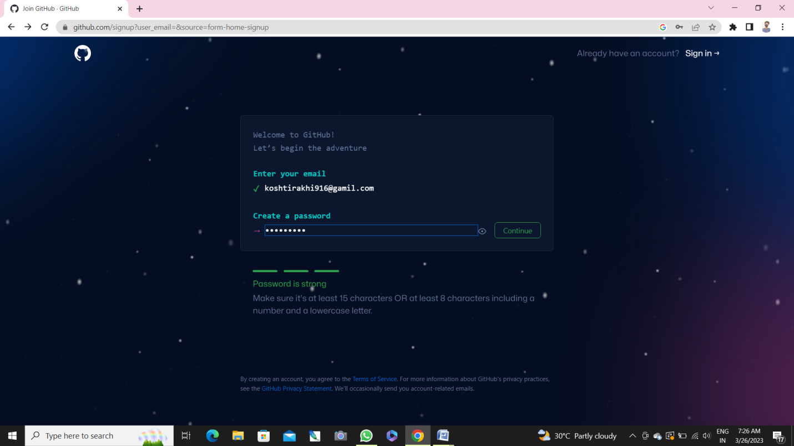

4.enter the username

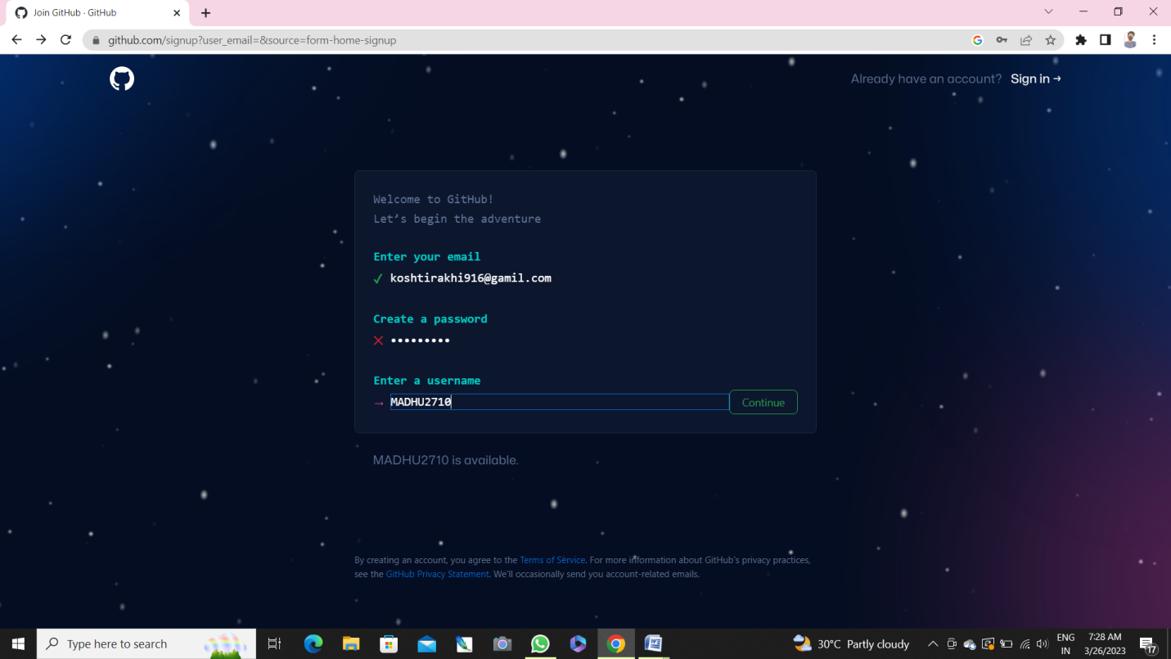

5. would you like to receive product update and announcements via emailtype “y” for yes or “n” for no

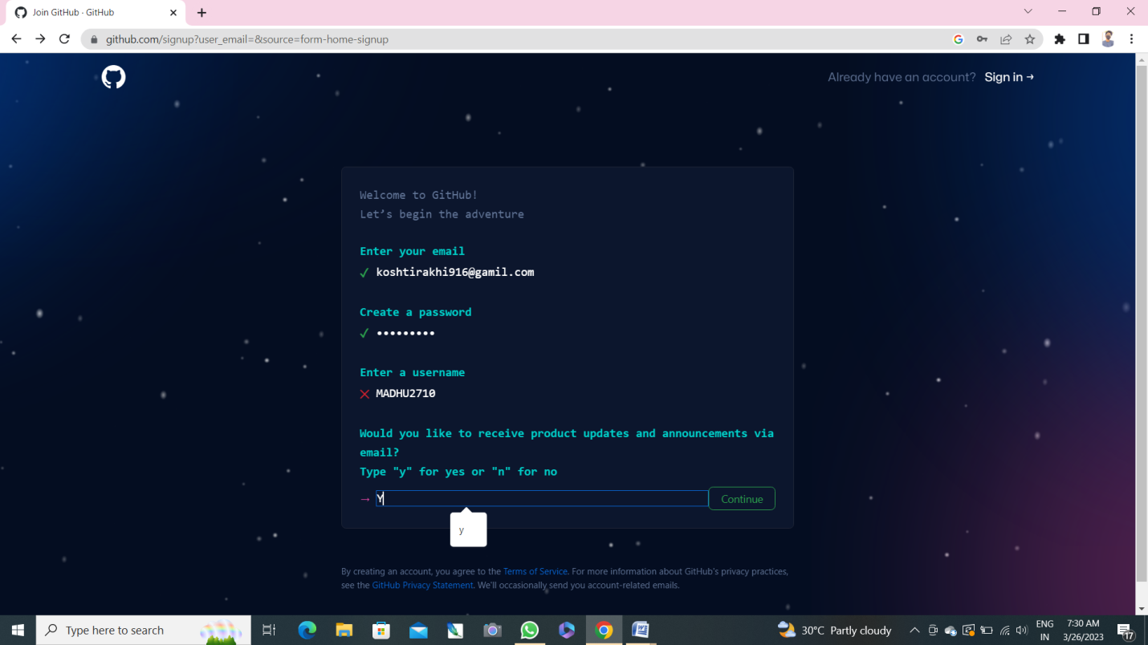

6. Verify your Account

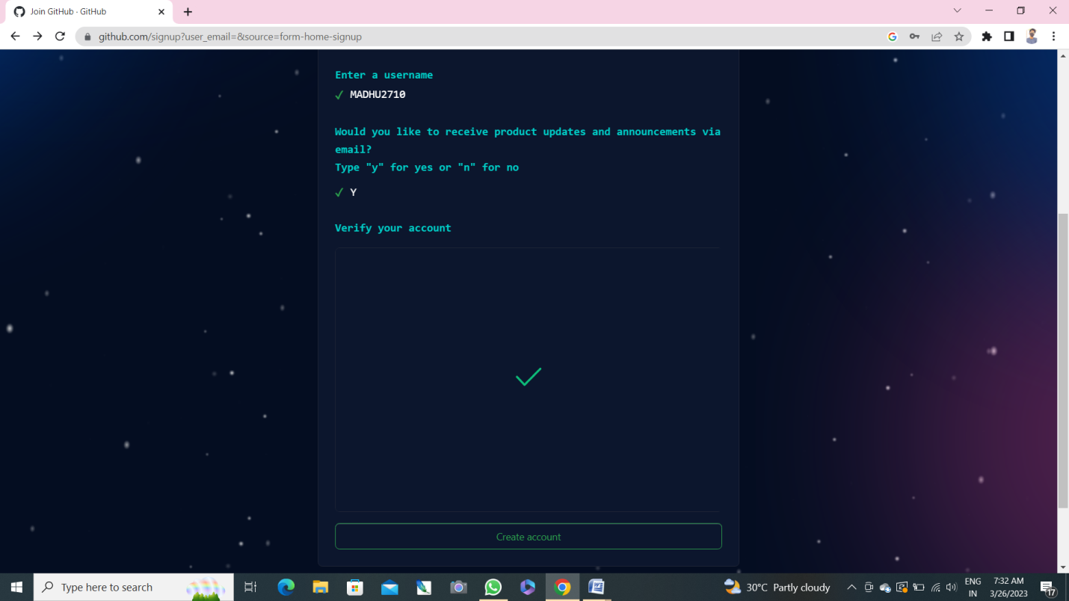

7.Verify you account by solving a pizzle. Select ta Start puzzle buttom to do so, and then follow the promts.

After your verify account .select the current account button.

Next , Github sends a launch code to your email address. Type that launch code in the enter code

Djialog, and then press enter.

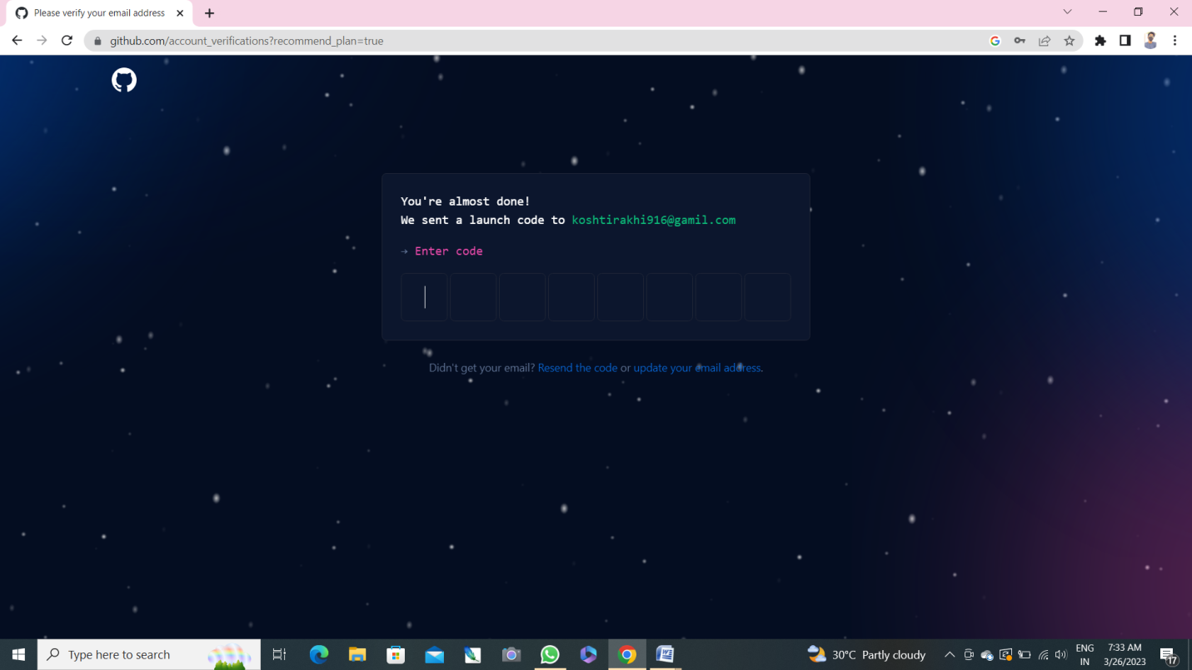

Gihub asks your some question to help tailor your exoeruence.choose the answers that apply to you in the follwing dialogs:

* How manu team memvers will be woking with you?
* What specific features are you interested in using?

8.On the when teams collaborate ans shop screen, you can choose whether you want to use the Free account. To choose the free account select the skip personalization button

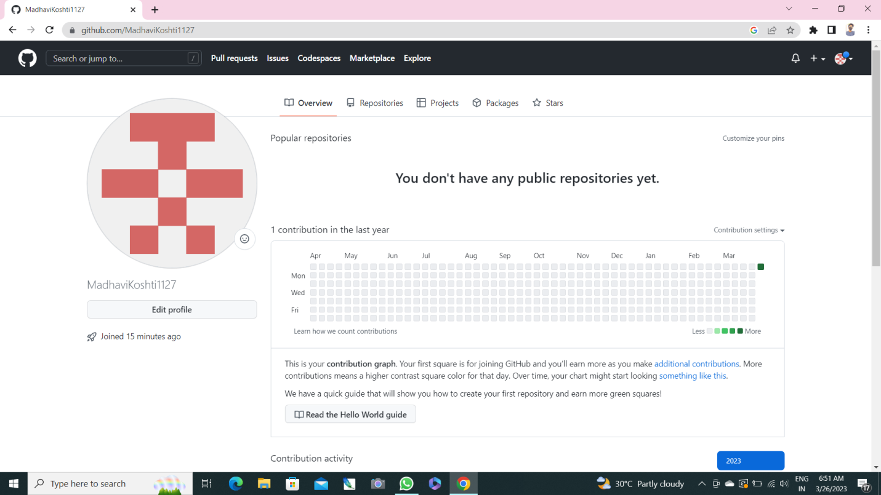

Congragulation! You’ve successfully create your gothub account

**Paste the screen of email which you had sended to your friends through github.**

